**MBAN 6120 Assignment 2**

**Chapter 5 Level I and II Exercises**

1 a)

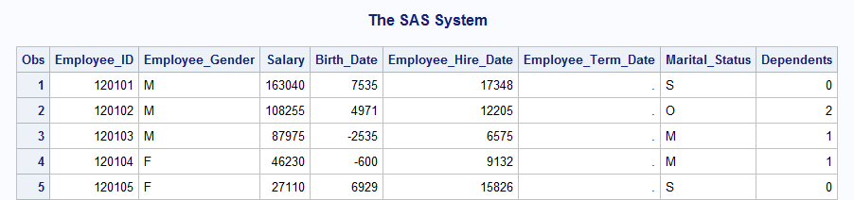

b)

**proc** **print** data=orion.employee_payroll;

var Employee_ID Salary Birth_Date Employee_Hire_Date;

**run**;

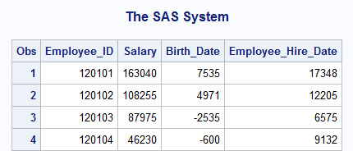

c)

**proc** **print** data=orion.employee_payroll;

var Employee_ID Salary Birth_Date Employee_Hire_Date;

format Salary dollar11.2 Birth_Date mmddyy10.

Employee_Hire_Date date9.;

**run**;

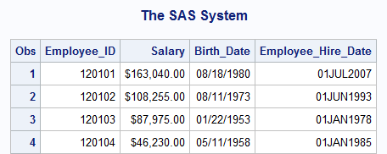

2

title1 'US Sales Employees';

title2 'Earning Under $26,000';

**proc** **print** data=orion.sales label noobs;

where Country='US' and Salary < **26000**;

var Employee_ID First_Name Last_Name Job_Title Salary Hire_Date;

label First_Name='First Name' Last_Name='Last Name'

Job_Title='Title'

Hire_Date='Date Hired';

format Salary dollar10. Hire_Date monyy7.;

**run**;

title;

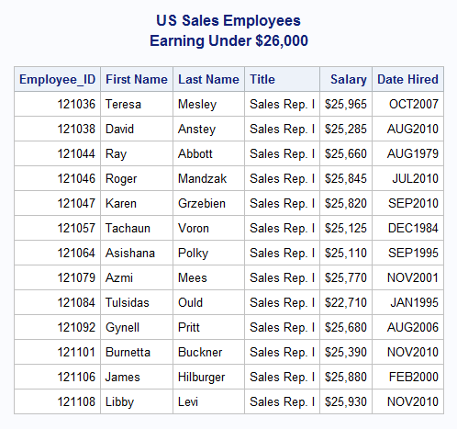

4 b)

**proc** **format**;

value $gender 'F' = 'Female'

'M' = 'Male';

**run**;

4 c)

**proc** **format**;

value mname **1** = 'January'

**2** = 'February'

**3** = 'March';

**run**;

d)

title 'Employees with Birthdays in Q1';

**proc** **print** data = Q1Birthdays;

var Employee_ID Employee_Gender BirthMonth;

format Employee_Gender $gender. BirthMonth mname.;

**run**;

title;

e)

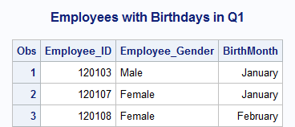

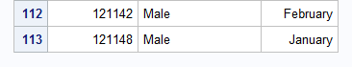

5 b)

**proc** **format**;

value $gender 'F' = 'Female'

'M' = 'Male'

Other = 'Invalid code';

**run**;

5 c)

**proc** **format**;

value salrange **.** = 'Missing salary'

**20000** -< **100000** = 'Below $100,000'

**100000** - **500000** = '$100,000 or more'

Other = 'Invalid salary';

**run**;

d)

**proc** **format**;

value $gender 'F' = 'Female'

'M' = 'Male'

other = 'Invalid code';

value salrange **.** = 'Missing salary'

**20000** -< **100000** = 'Below $100,000'

**100000** - **500000** = '$100,000 or more'

other = 'Invalid salary';

**run**;

title1 'Salary and Gender Values';

title2 'for Non-Sales Employees';

**proc** **print** data = orion.nonsales;

var Employee_ID Job_Title Salary Gender;

format Salary salrange. Gender $gender.;

**run**;

title;

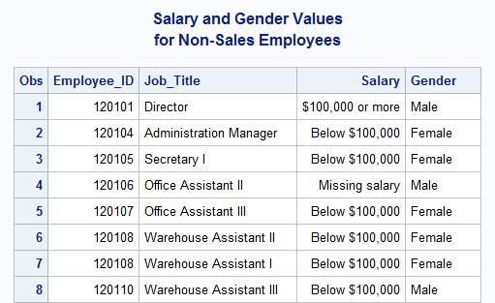

**Chapter 6 Level I and II Exercises**

1 a)

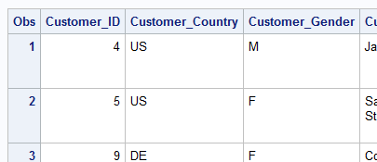

The name of variable that contains gender values is **Customer_Gender**

The two observed gender values are **M** and **F**

b)

**data** work.youngadult;

set orion.customer_dim;

where Customer_Gender = 'F';

**run**;

NOTE: There were 30 observations read from the data set ORION.CUSTOMER_DIM.

WHERE Customer_Gender='F';

NOTE: The data set WORK.YOUNGADULT has 30 observations and 11 variables.

NOTE: DATA statement used (Total process time):

real time 0.18 seconds

cpu time 0.04 seconds

c)

**data** work.youngadult;

set orion.customer_dim;

where Customer_Gender = 'F' and

Customer_Age between **18** and **36**;

**run**;

NOTE: There were 15 observations read from the data set ORION.CUSTOMER_DIM.

WHERE (Customer_Gender='F') and (Customer_Age>=18 and

Customer_Age<=36);

NOTE: The data set WORK.YOUNGADULT has 15 observations and 11 variables.

NOTE: DATA statement used (Total process time):

real time 0.03 seconds

cpu time 0.03 seconds

1 d)

**data** work.youngadult;

set orion.customer_dim;

where Customer_Gender = 'F' and

Customer_Age between **18** and **36** and

Customer_Group contains 'Gold';

**run**;

NOTE: There were 5 observations read from the data set ORION.CUSTOMER_DIM.

WHERE (Customer_Gender='F') and (Customer_Age>=18 and

Customer_Age<=36) and Customer_Group contains 'Gold';

NOTE: The data set WORK.YOUNGADULT has 5 observations and 11 variables.

NOTE: DATA statement used (Total process time):

real time 0.03 seconds

cpu time 0.03 seconds

e)

**data** work.youngadult;

set orion.customer_dim;

where Customer_Gender = 'F' and

Customer_Age between **18** and **36** and

Customer_Group contains 'Gold';

Discount = **.25**;

**run**;

f)

**proc** **print** data = work.youngadult;

var Customer_Name Customer_Age

Customer_Gender Customer_Group Discount;

id Customer_ID;

**run**;

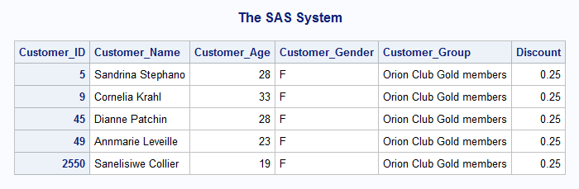

2 a)

**data** work.assistant;

set orion.staff;

**run**;

b)

**data** work.assistant;

set orion.staff;

where Job_Title contains 'Assistant' and Salary < **26000**;

**run**;

c)

**data** work.assistant;

set orion.staff;

where Job_Title contains 'Assistant' and Salary < **26000**;

Increase = Salary\***.10**;

New_Salary = Salary + Increase;

**run**;

d)

**proc** **print** data = work.assistant;

id Employee_ID;

var Job_Title Salary Increase New_Salary;

format Salary Increase New_Salary dollar10.2;

**run**;

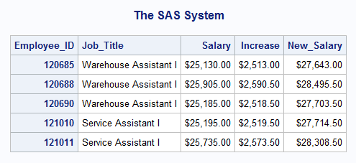

4 b)

**data** work.increase;

set orion.staff;

where Emp_Hire_Date >= **'01JUL2010'd**;

Increase = Salary * **0.10**;

NewSalary = Salary + Increase;

**run**;

NOTE: There were 72 observations read from the data set ORION.STAFF.

WHERE Emp_Hire_Date>='01JUL2010'D;

NOTE: The data set WORK.INCREASE has 72 observations and 12 variables.

NOTE: DATA statement used (Total process time):

real time 0.01 seconds

cpu time 0.00 seconds

c)

**data** work.increase;

set orion.staff;

where Emp_Hire_Date >= **'01JUL2010'd**;

Increase = Salary * **0.10**;

if Increase > **3000**;

NewSalary = Salary + Increase;

**run**;

d)

**data** work.increase;

set orion.staff;

where Emp_Hire_Date >= **'01JUL2010'd**;

Increase = Salary * **0.10**;

if Increase > **3000**;

NewSalary = Salary + Increase;

keep Employee_ID Emp_Hire_Date Salary Increase NewSalary;

**run**;

e)

**data** work.increase;

set orion.staff;

where Emp_Hire_Date >= **'01JUL2010'd**;

Increase = Salary * **0.10**;

if Increase > **3000**;

NewSalary = Salary + Increase;

label Employee_ID = 'Employee ID'

Emp_Hire_Date = 'Hire Date'

NewSalary = 'New Annual Salary';

keep Employee_ID Emp_Hire_Date Salary Increase NewSalary;

**run**;

f)

**data** work.increase;

set orion.staff;

where Emp_Hire_Date >= **'01JUL2010'd**;

Increase = Salary * **0.10**;

if Increase > **3000**;

NewSalary = Salary + Increase;

label Employee_ID = 'Employee ID'

Emp_Hire_Date = 'Hire Date'

NewSalary = 'New Annual Salary';

format Salary NewSalary dollar10.2 Increase comma5.;

keep Employee_ID Emp_Hire_Date Salary Increase NewSalary;

**run**;

g)

**proc** **contents** data = work.increase;

**run**;

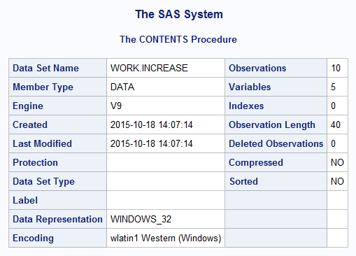

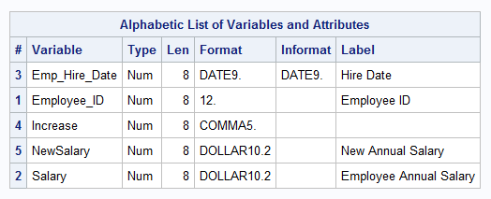

h)

These labels and formats were inherited from the input data set.

i)

**proc** **print** data=work.increase split=' ';

**run**;

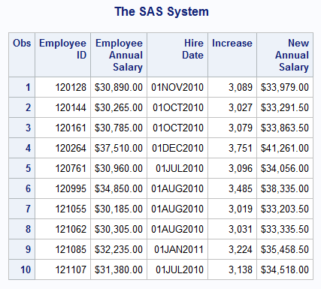  
  
5 a)

**data** work.delays;

set orion.orders;

**run**;

b)

**data** work.delays;

set orion.orders;

Order_Month = month(Order_Date);

**run**;

c)

**data** work.delays;

set orion.orders;

where Order_Date + **4** < Delivery_Date

and Employee_ID = **99999999**;

Order_Month = month(Order_Date);

if Order_Month = **8**;

**run**;

d)

**data** work.delays;

set orion.orders;

where Order_Date + **4** < Delivery_Date

and Employee_ID = **99999999**;

Order_Month = month(Order_Date);

if Order_Month = **8**;

keep Employee_ID Customer_ID Order_Date Delivery_Date Order_Month;

**run**;

e)

**data** work.delays;

set orion.orders;

where Order_Date + **4** < Delivery_Date

and Employee_ID = **99999999**;

Order_Month = month(Order_Date);

if Order_Month = **8**;

label Order_Date='Date Ordered'

Delivery_Date='Date Delivered'

Order_Month='Month Ordered';

keep Employee_ID Customer_ID Order_Date Delivery_Date Order_Month;

**run**;

f)

**data** work.delays;

set orion.orders;

where Order_Date + **4** < Delivery_Date

and Employee_ID = **99999999**;

Order_Month = month(Order_Date);

if Order_Month = **8**;

label Order_Date='Date Ordered'

Delivery_Date='Date Delivered'

Order_Month='Month Ordered';

format Order_Date Delivery_Date mmddyy10.;

keep Employee_ID Customer_ID Order_Date Delivery_Date Order_Month;

**run**;

5 g)

**proc** **contents** data = work.delays;

**run**;

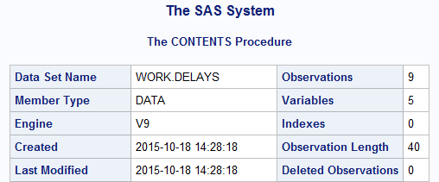

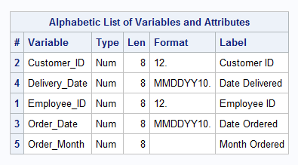

h)

**proc** **print** data = work.delays;

**run**;

